



Training Manual
Index

Daily Process…………………………………….. 3
Receive EDI Data ……………………………….. 4
Purchase Order Printing and Processing ………... 7
Checking Logs …………………………………. 8
PO Confirmation ……………………………….. 10
Generate ASN and Print Label…………………. 10
Invoice Processing …………………………….. 15
Sending EDI Data to Trading Partner …………. 16
Reports ………………………………………… 17
Daily Process:

The Daily Process can be summarized in the following steps:

- Receive EDI Data and Send FA
- PO Printing & Processing
- Generate ASN & Print Labels
- Sending EDI to Trading Partner
1. Receive EDI Data

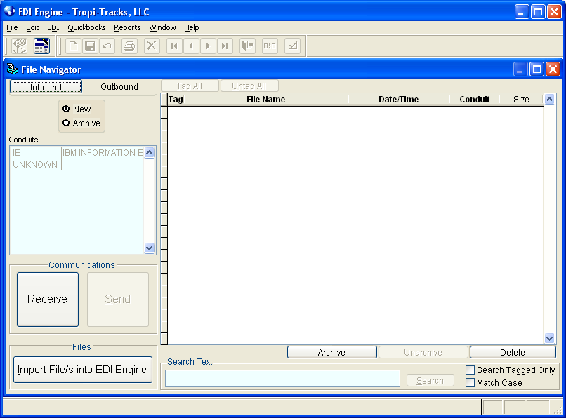

- Open File Navigator
- Click on Receive
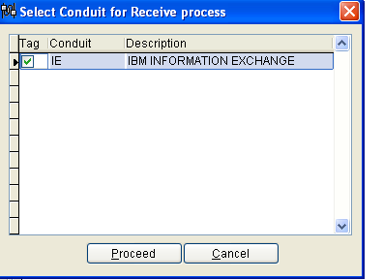
- Check the desired conduits
- Click on Proceed
- After the communication process ends, the Log Report window will appear
At this point, The EDI data has been succesfuly received through the communication conduit. The next step is to import the EDI Data into EDI Engine.

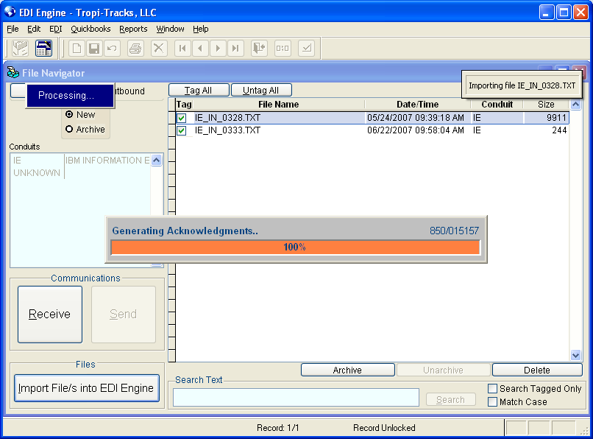

Click on “Tag All”
Click on “Import File/s into EDI Engine”
The log report screen will pop again to check errors.
After sucessfuly importing the POs into EDI Engine, the FA (997) gets generated automatically. Now it’s time to send these FAs to the trading partner.

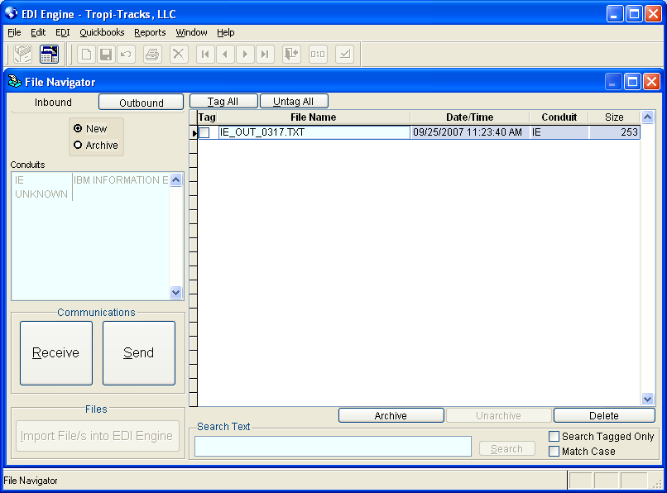

Go to Outbound, Tag all and click on Send.
A Message Box will appear.

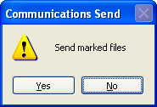

Click on “Yes” to send the tagged file/s

2. Purchase Order Printing and Processing

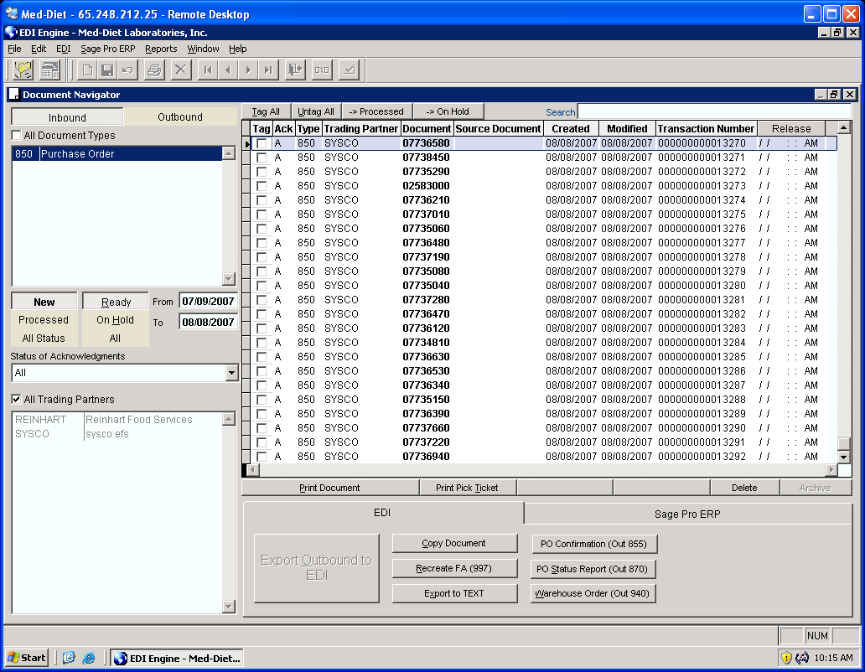

Documents can be viewed based on the criteria in the left section of the screen as follows:
- Direction (Inbound or Outbound)
- Document Type (Purchase Order, Invoice, ASN, etc…)
- Document Status (New, Processed, Ready, On Hold)
- Document Creation Date in EDI Engine
- Document Status (Accepted, Accepted With Errors, Rejected, Not Acknowledged)
- Trading Partner

To view a document, double click on it.

To print a document or multiple documents, tag them individually or click on the “Tag All” button and then press the “Print Document” button

Document that are “Processed” and “Ready” can be archived

Checking Logs

After every process in EDI Engine, the “Log Report” window appears.

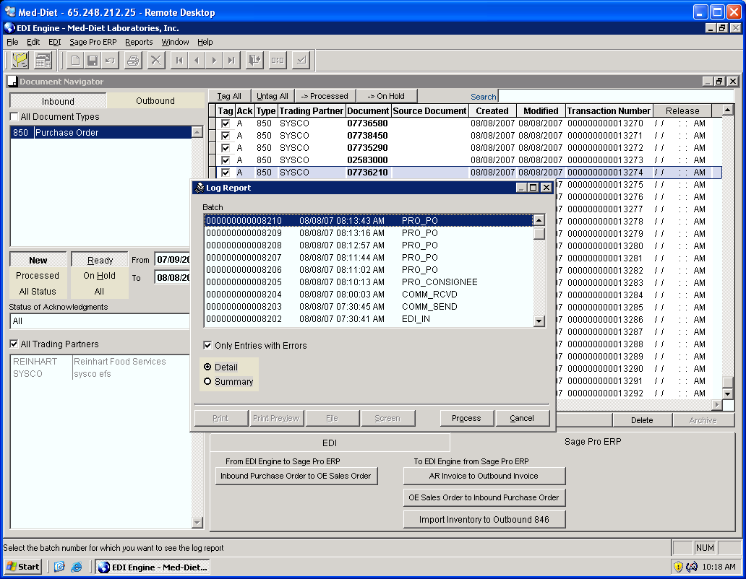

To check for Errors:
- Tag “Only Entries with Errors”
- Click on Process
Checking Logs - Continued

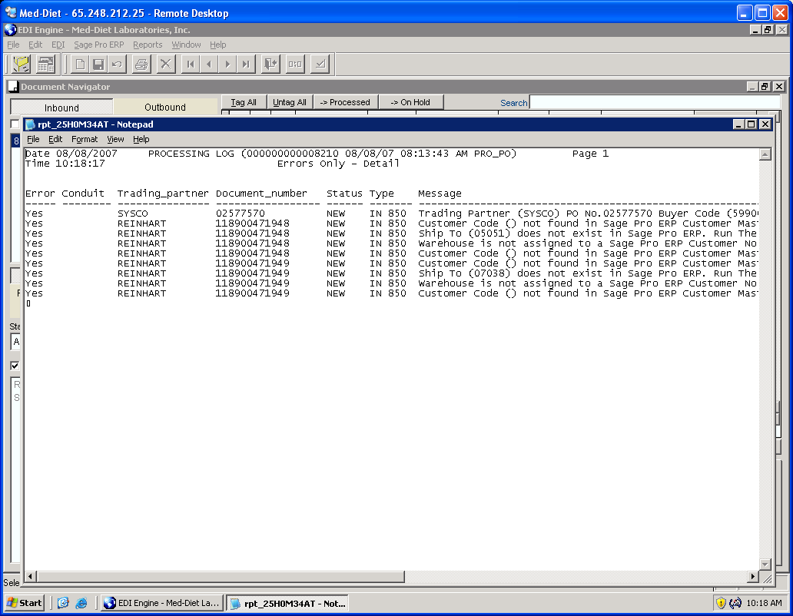

If there are any errors, a notepad document will show up with the errors found.
Only the Status of the Documents with errors will be changed to “On Hold”

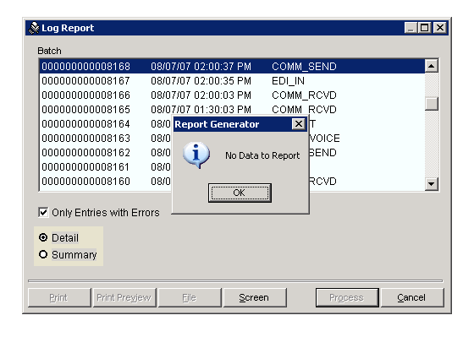

If there are no errors, a message box will appear with “No Data to Report”
4. Generation of PO Confirmation

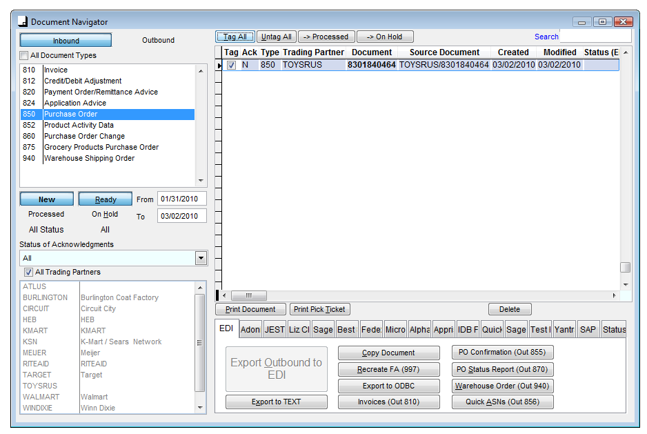

Tag the Purchase order(s) and then click on the “PO Confirmation (Out 855)” button

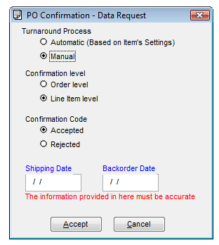

Select “Manual” and “Line Item Level” then choose whether you are accepting or rejecting the items and then click on “Accept”, the 855 will be created and you can locate it in the Document Navigator in the outbound section.
5. Generate ASN & Print Labels

If you are not shipping complete or palletizing or In the Document Navigator,
- Right click on the PO
- Select “Pack into ASN (856)”
- The packing wizard will appear
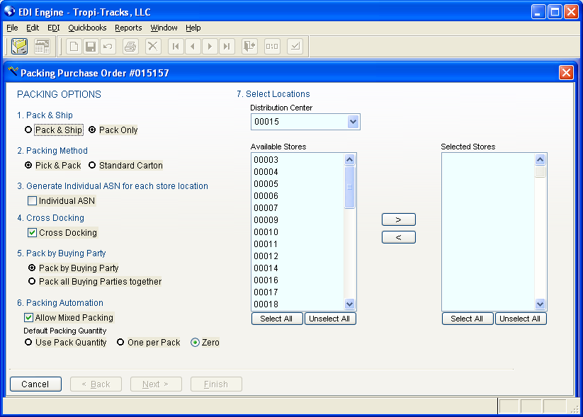

- Pack & Ship
  - Pack & Ship: Packs the current PO and generate ASN. This option is to be selected if shipping 1 PO by itself.
  - Pack only: Packs the current PO and holds it to be combined with other POs that are being packed. This option is to be selected if shipping multiple POs together in one shipment and the Trading Partner requires to send only 1 ASN.
- Packing Method
Depending on the way you pack your items and the Trading partner requirements. You can either select “Pick & Pack” or “Standard Carton”
- Generate Individual ASN for each store location
If selected, a different ASN will be created for each store.

- Cross Docking
Will allow you to pack each store by itslef.
- Pack by Buying Party
If “Pack all buying parties together” is selected, the Cross Docking option will be disabled. The system will not separate items by store while packing.
- Packing Automation
  - Allows you to mix items together in a box if “Allow Mixed Packing” is checked.
  - Default packing quantity can be specified.
- Select Location
Select the stores that you will be shipping to

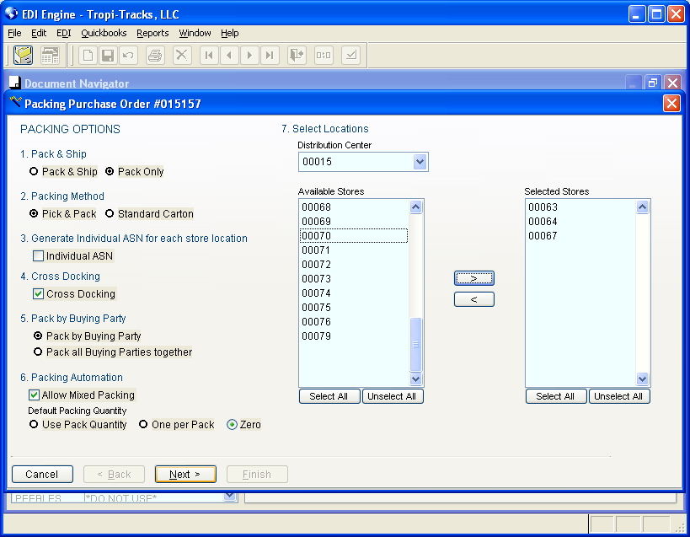

Click on the Arrow to move to the “Selected Stores” area
Click on Next

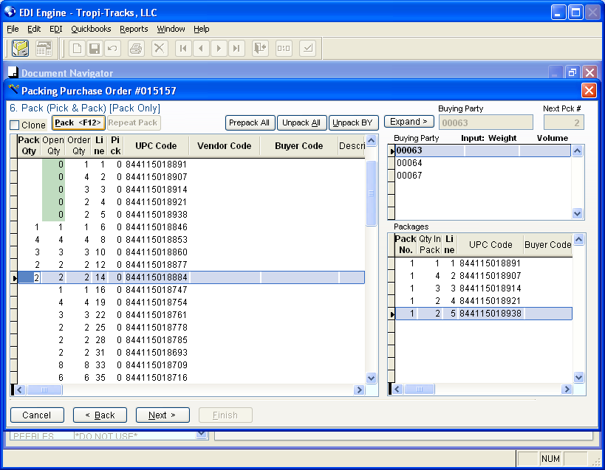

- Specify quantities for each carton
- Click on “Pack <F12>” button or push the “F12” button on the keyboard
  - If “Allow Mixed Packing” option is selected, you can combine more than one item in a box, the quantities entered in the “Pack Qty” field will be all combined in one carton or package and they will show in the “Packages” area with the same “Pack No.”
  - If “Allow Mixed Packing” is not checked, you can only pack one item per carton
- After packing all the items that will be shipped, click on “Next”

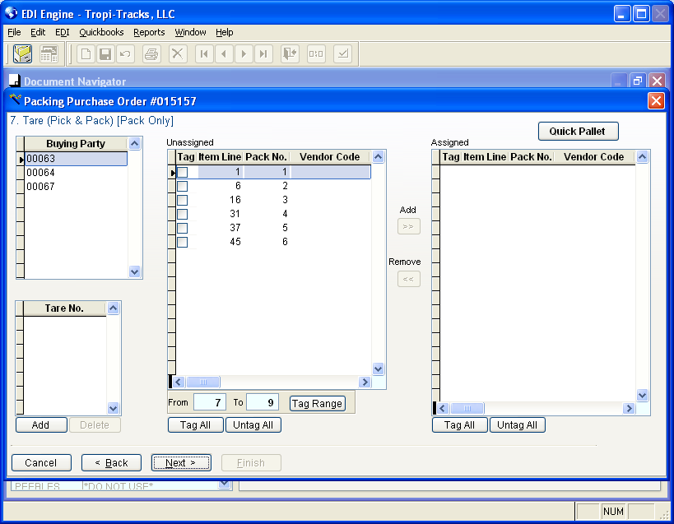
1
3

To create a pallet:
- Click on the “Add” button
- Tag the Cartons that need to go on that palled
- Click on “Add”

You can also click on “Quick Pallet” if all the carton are going on 1 pallet. This will create a pallet and assign all the cartons to this pallet.

After finishing the pallets, Click on “Next”

If pallets are not used, you can click on “Next” without making any changes to this screen.

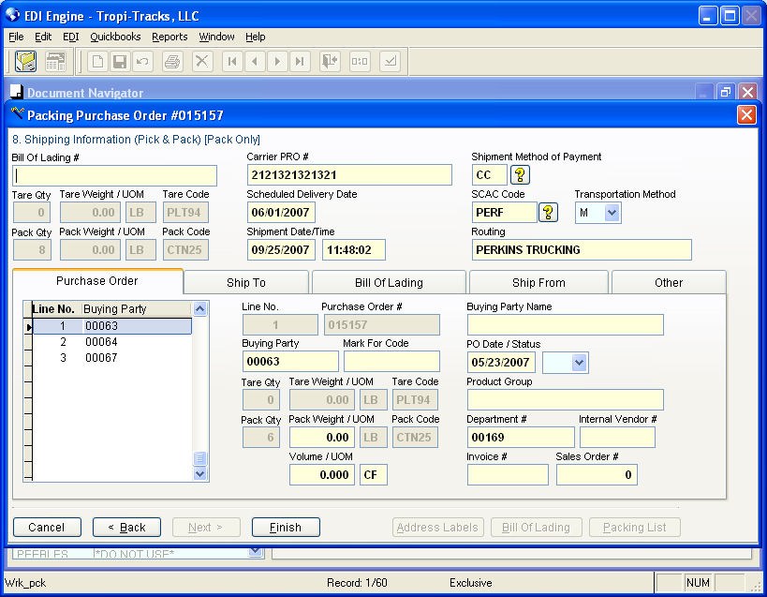

Enter the Bill of Lading # and the Carrier Pro #
Click on “Finish”

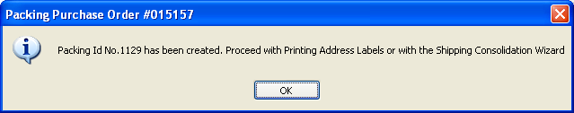

Click on “Ok”
The “Address Labels”, “Bill of Lading” and “Packing List” buttons will be enabled.
Clicking on the Address Labels button will print the UCC128 labels
Clicking on the Bill of Lading button will print the Bill of Lading
Clicking on the Packing List button will print the packing list.

6. Quick ASN Generation

You can use the Quick ASN option if:
- You are shipping complete
- You are not mixing items in Boxes
- You are not palletizing your order.

You will need to define the packing information for each item in the EDI Item (“EDI” → “Items” → “Items Maintenance”) on the trading partner (“EDI” → “Setup” → “Trading Partner” → “Packing” tab then “Packing Automation” tab and define the “Packing Scheme” to either use 1 per pack or use the Pack quantity. Also check the option to calculate the Weight based on the weight defined in the EDI Item configuration.
6. Sending EDI To Trading Partner

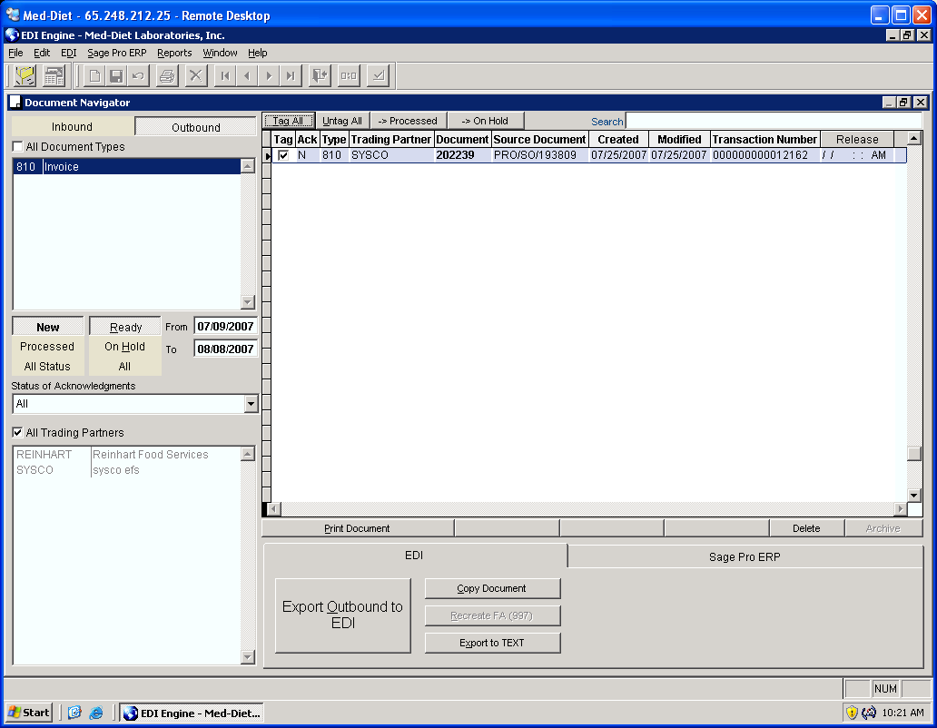

In order to send invoices and ASNs to customer, go to the Document Navigator and select Outbound.

- Make sure to select “New” and “Ready”
- Tag the invoices that need to be sent
- Click on “Export Outbound to EDI”

If there are no errors, the document status will be changed from “New” to “Processed”
If there are errors, the document status will be changed from “Ready” to “On Hold”

After exporting the invoices to EDI and checking the Logs, it’s always recommended to view the “On Hold” section to make sure there are no documents there.

“On hold” Documents need to be fixed, change their status to “Ready” and exported to EDI one more time.
Reports

EDI Engine provides several reports that ensure the precision of the day to day operations.
- Transmission Summary Report
- Reconciliation of Functional Acknowledgments
- Management Reports

1. Transmission Summary Report:
The Transmission Summary Report list all the transmission you have received from all your trading partners. Any transmission received has an ISA Control number and a GS control number. The control numbers are usually in sequence. The sequence can be either by trading partner only or by Trading partner and document type.

To run this report, select the “Reports” Menu, Select “EDI” then click on “Transmission Summary”
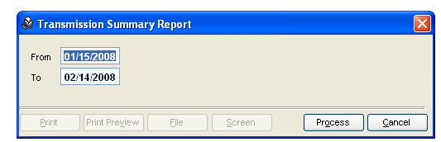

The report by default lists the transmissions of the last 30 days, click on process. You can view the result on the screen or print it.
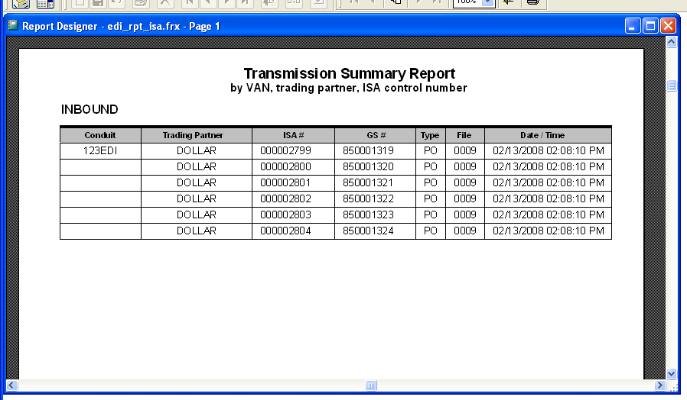
2. Reconciliation of Functional Acknowledgments Report:
The Reconciliation of Functional Acknowledgments report list all the unacknowledged transmission that were exported to EDI from EDI Engine. Each transmission sent from EDI should be acknowledged within 24 hours. If the reports shows any unacknowledged documents after 24 hours of their transmission, contact the trading partner immediately to ensure the receipt of the document.

To run this report, select the “Reports” Menu, Select “EDI” then click on “Reconciliation of Functional Acknowledgments”

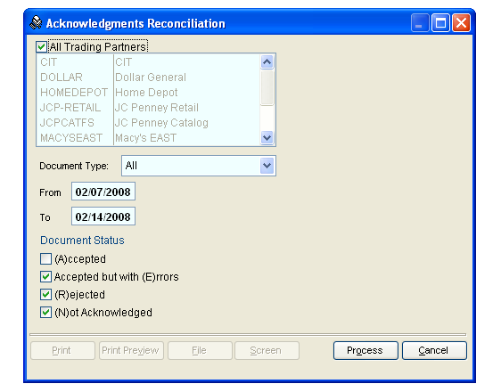

This report can be viewed by trading partner and by document type.
By default, the report lists the unacknowledged transmissions, the transmissions accepted with errors and the rejected transmissions (documents) for all trading partner during the last week.
The unacknowledged documents will have the Letter “N”, the Documents accepted with errors will have the letter “E”, and the rejected documents will have the letter “R”.
Each document has 2 statuses, the “Original Status” and the “Last Status”. If you send a document more than one time, the original status will show the first acknowledgment status while the last status will show the current status after the second transmission.
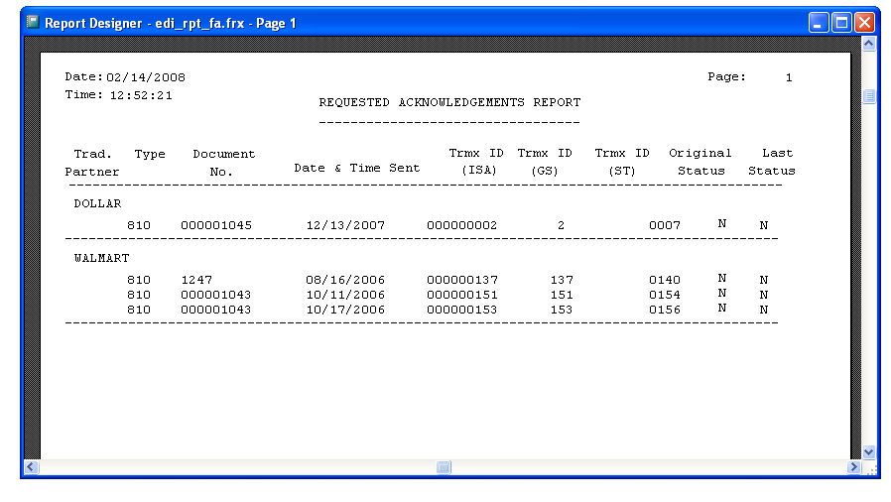

3. Management Report
EDI Engine comes with several management reports for the Purchase Orders, Invoices and ASN. These reports can be accessed from the “Reports” menu, select “Management Reports”.
Additional Information

When checking logs, the processes can be one of the followings:
- PRO_PO: Posting a Purchase Order to Sage Pro ERP
- PRO_CONSIGNEE: Synchronization of Location
- PRO_INVOICE: Importing Invoices from Sage Pro ERP
- COMM_RCVD: Communication Receive
- COMM_SEND: Communication Send
- EDI_IN: Importing EDI raw Data into EDI Engine
- EDI_OUT: exporting documents to EDI

